**#T129. Read and write file using two different way.**

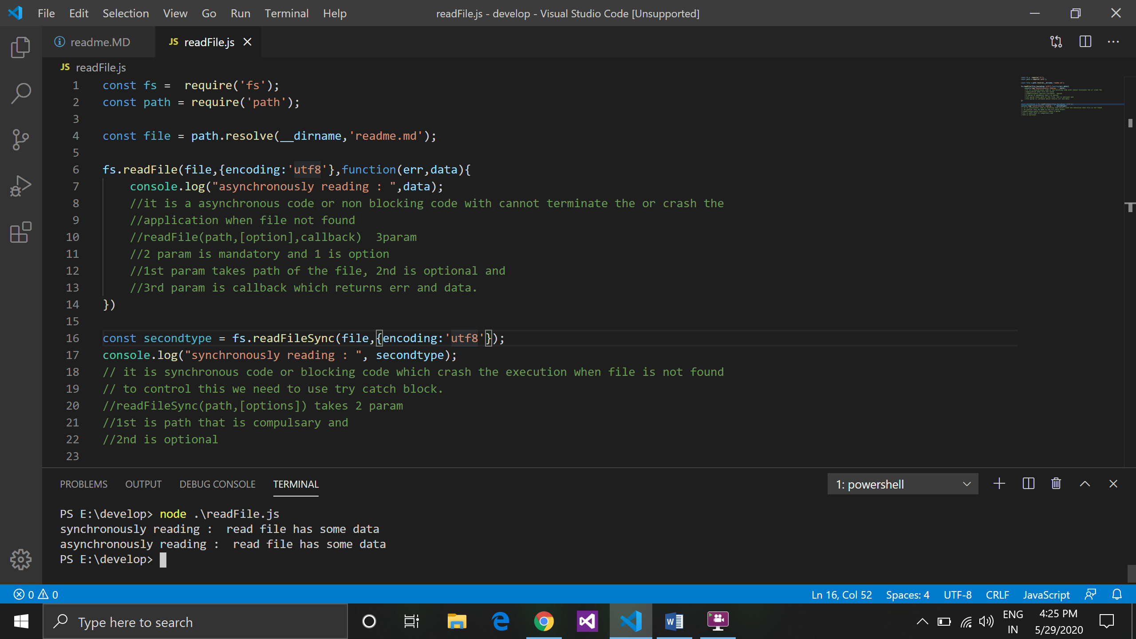

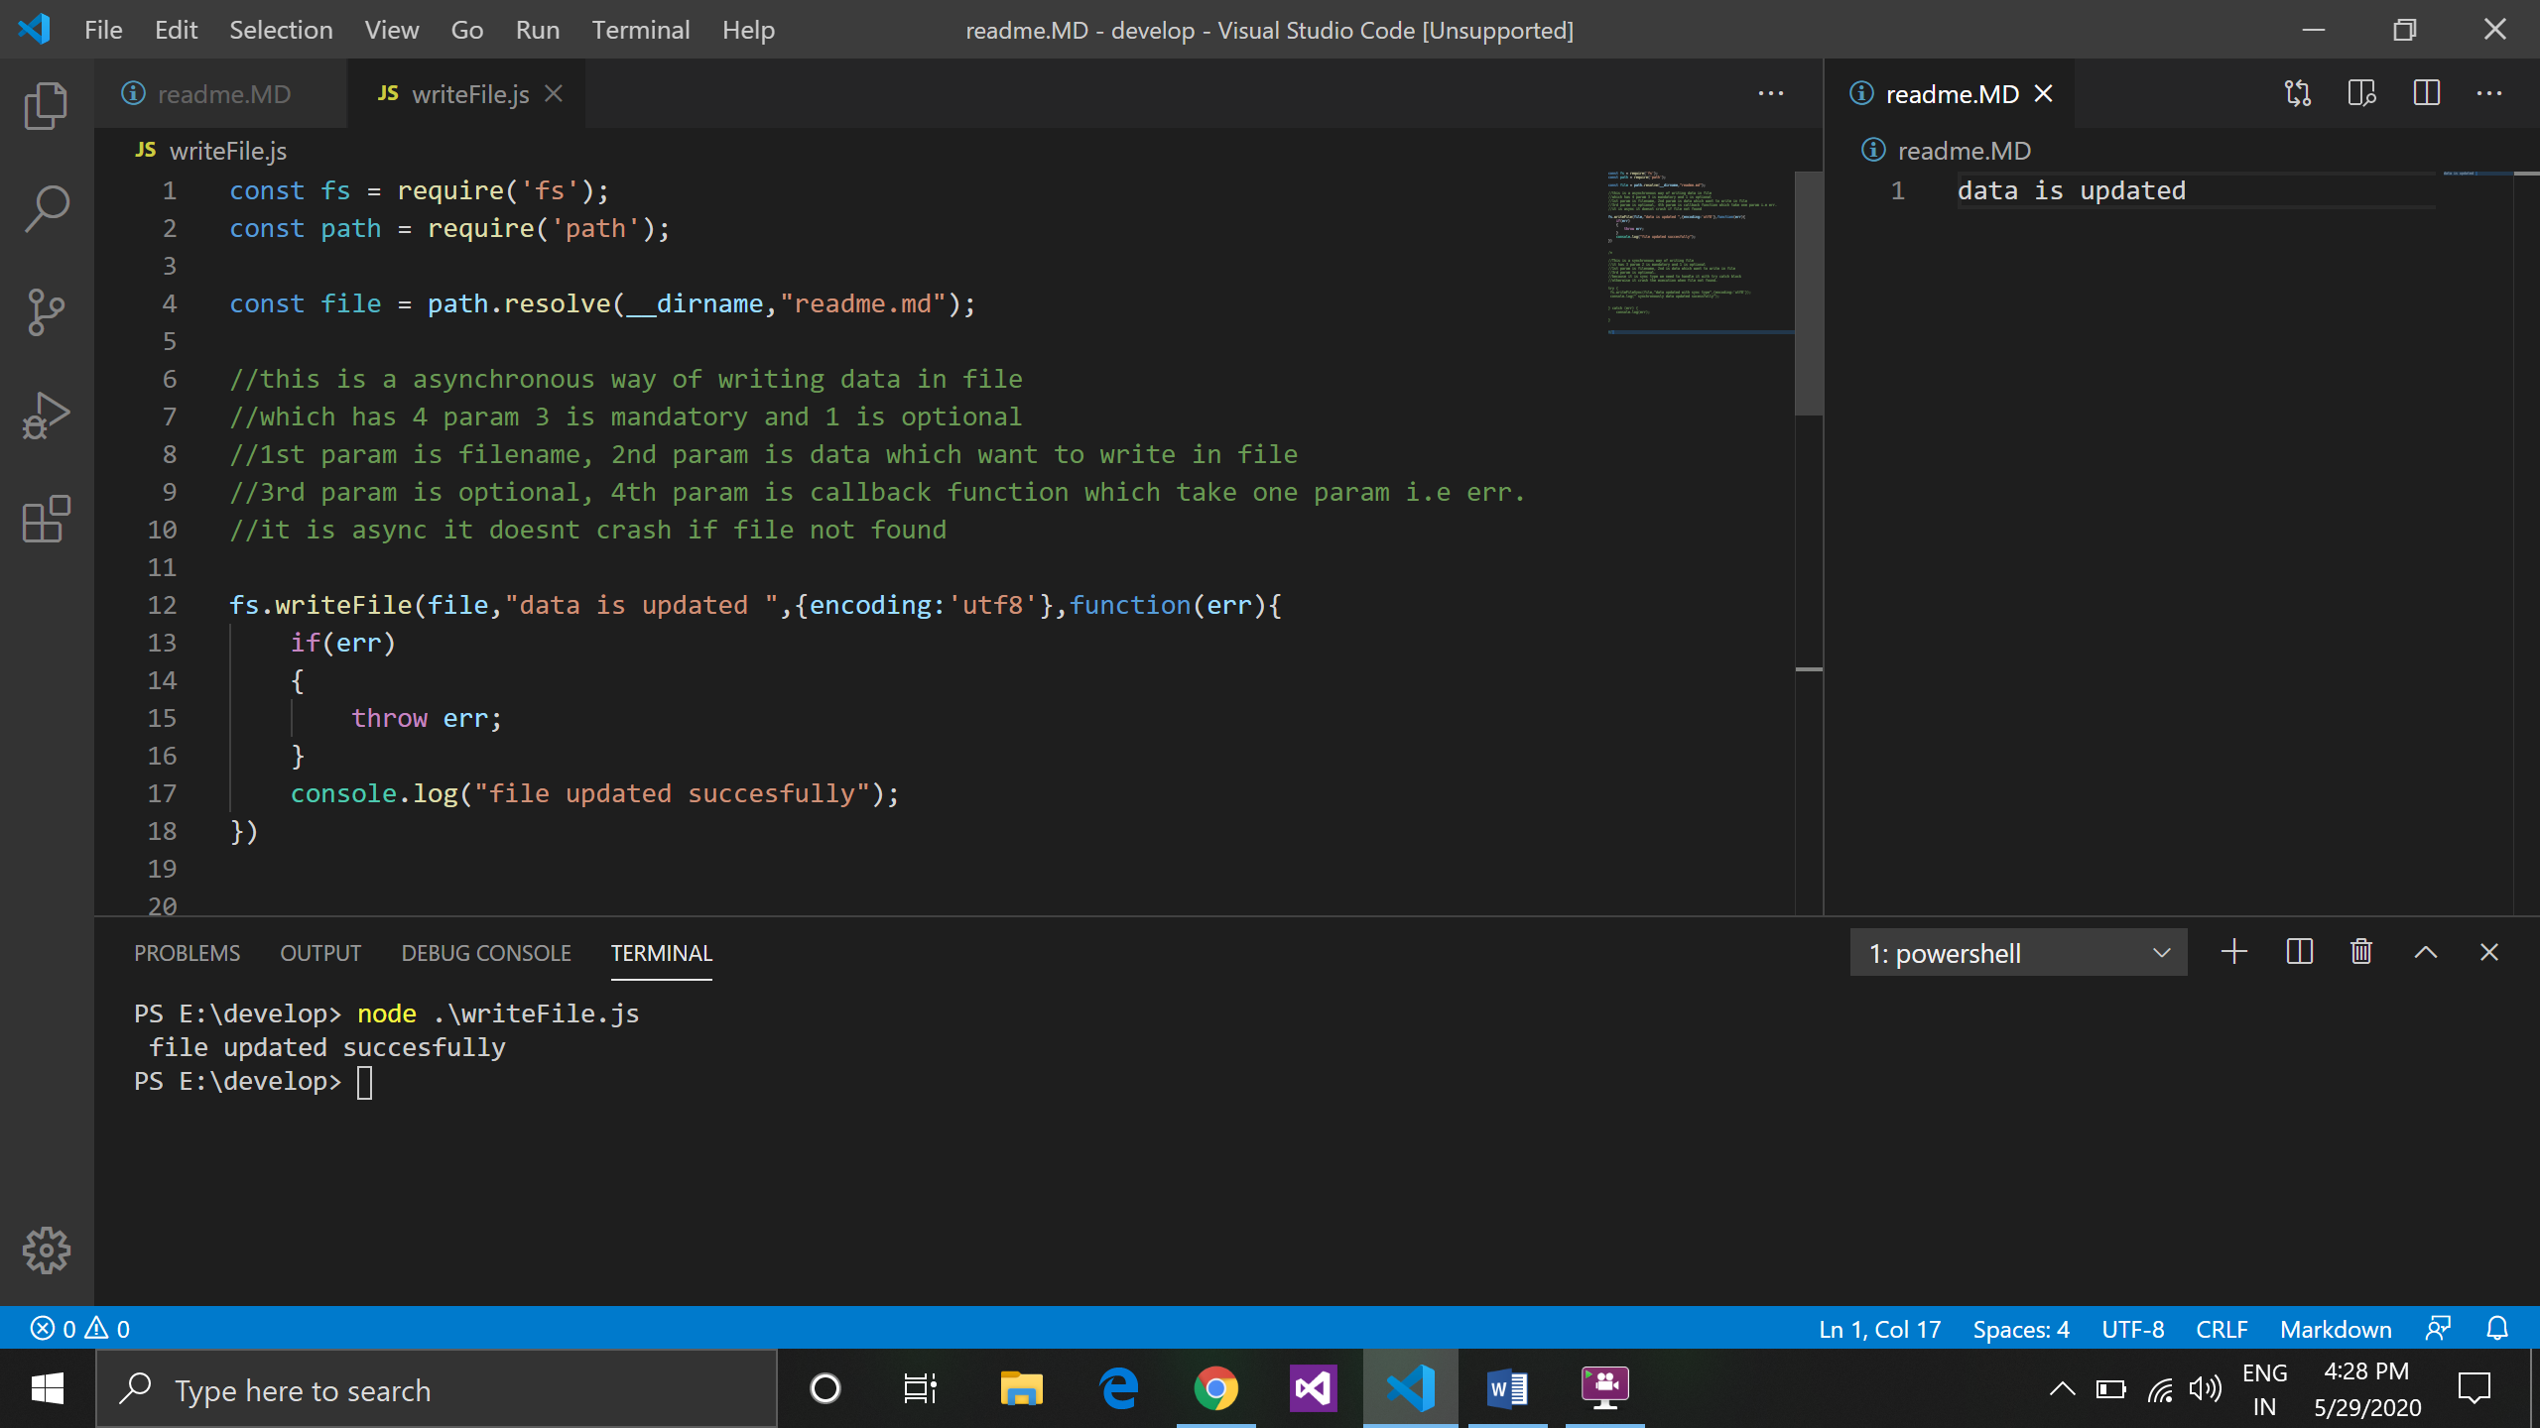

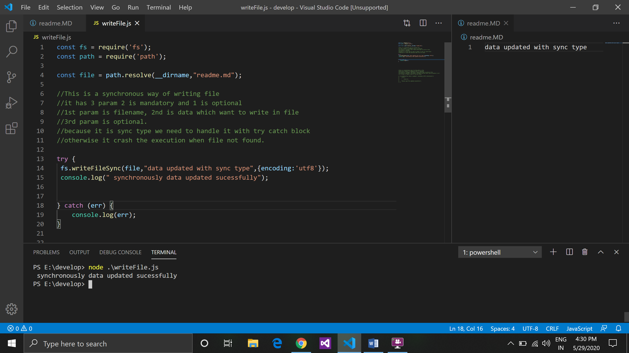

**#T130. Write pseudo code for fs.writeFile and fs.writeFileSync method.**

**fs.writeFile(file, data, { encoding : "urf8"}, function(err,data){**

if(err){

console.log(err);

}else{

console.log(data);

}

});

//Pseudo code

const fs = {

writeFile : function(a, b, c function){

function(err, data)

{

if(err){

console.log(err);

}else{

console.log(data);

}

}

}

}

*Note: writeFile is a non-blocking or asynchronous type of code.*

[**fs.writeFileSync(file, data[, options])**](https://nodejs.org/dist/latest-v14.x/docs/api/fs.html#fs_fs_writefilesync_file_data_options)**:**

**//pseudo code**

Try{

const fs = {

writeFileSync : function(a,b,c)

{

fs.writefilesync(a,”some data”, {encoding: ‘utf8’})

}

}

Catch(e)

{

}

*Note: writeFilesync is a synchronous type of code which can line by line.*

**#T131. What does absolute path and relative path mean?**

**Absolute path:**

* Absolute path is path which describe the complete location of the file form the root (full path).
* It represent the complete path of the file or folder like web address (<http://localhost:3000/api/read>)
* For e.g.
* In windows, all application stored in c drive, so if we are taking any application and search there absolute path so it gets like this c:\windows\programfiles\Nodejs\readme.md.

**Relative path:**

* Relative path is path that describe the location of the file related to the current location of the file or current working directory. It can be refer to the same location of the file.
* For e.g. : readme.md
* If you are working in some Nodejs directory, in this directory readme.md file is available so the path should be like this > “readme.md”. so it is search in the current working directory if found it can perform operation if not found it gives err. It will not find in some other directory.

**#T132. Create an API which reads content from a file and return using API in JSON as well as text.**

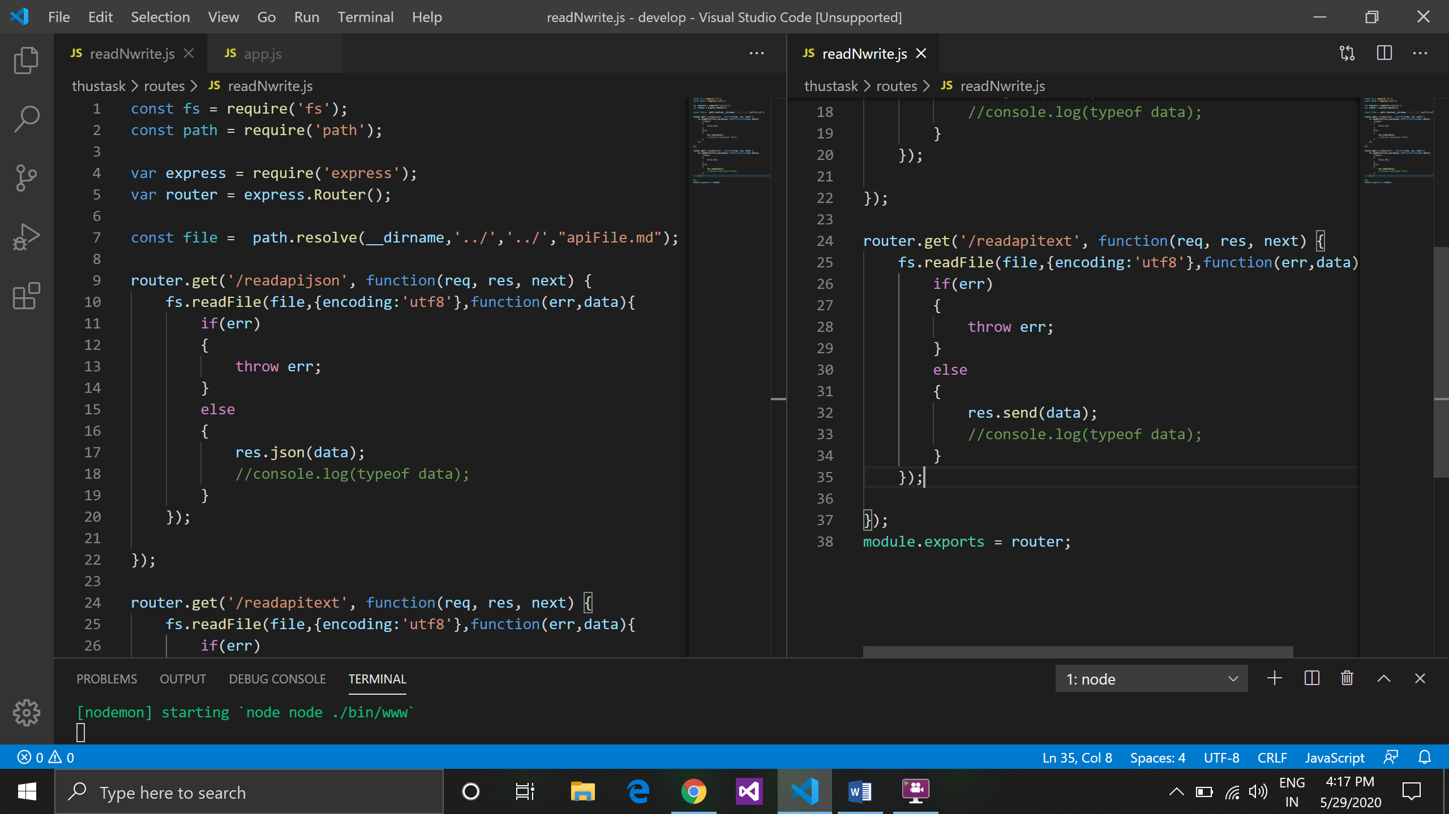

**Output in json format:**

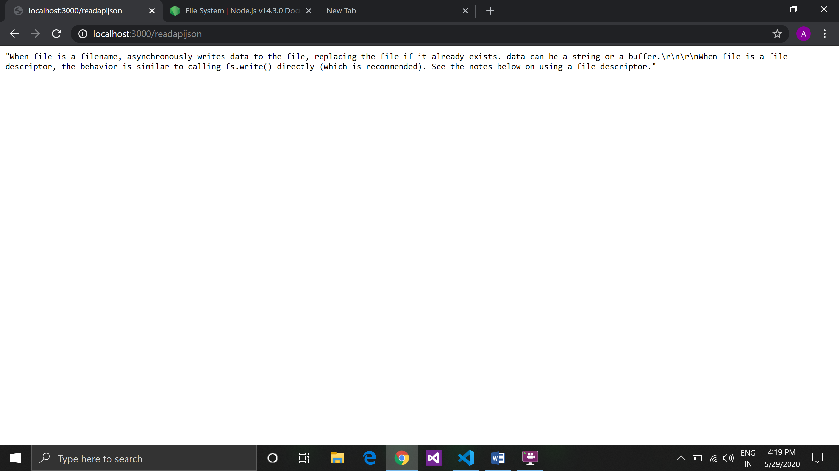

**Output in text format:**

